MANITOBA ARCHIVAL INFORMATION NETWORK

User Guide for AtoM 2.5.3

Last updated: July 2020

Digital Initiatives Committee, Association for Manitoba Archives
Webmaster@mbarchives.ca

Contents
STEP 1: General Information 2
1.1 Setting-up an Account in MAIN 2
1.2 Logging Into MAIN 2
1.3 Changing Your Password 3
1.4 Forgot Your Password? 4
1.5 De-activing an Account in Main 4
1.6 Saving Content in MAIN 4
STEP 2: Adding/Editing Authority Records 4
2.1 Identity Area 5
2.2 Description Area 6
2.3 Relationships Area 7
2.4 Control Area 8
STEP 3: Adding/Editing Archival Descriptions in MAIN 8
3.1 Title and Statement of Responsibility Area 9
3.2 Dates of Creation Area 10
3.3 Physical Description Area 11
3.4 Archival Description Area 11
3.5 Notes Area 11
3.6 Access Points 12
3.7 Control Area 12
3.8 Saving Your Description 13
STEP 4: Adding Child Levels to Existing Archival Descriptions 13
4.1 Creating Child Levels – Method One 13
4.2 Creating Child Levels – Method Two 14
STEP 5: Arrangement Features 15
5.1 Moving Levels of Description 15
5.1.2 Dragging and Dropping Child Levels 16
5.2 Duplicating Descriptions 16
5.3 Changing Slugs 17
5.4 Deleting Descriptions/Authorities 17
STEP 6: Finalizing your MAIN descriptions 18
6.1 Publishing Your Descriptions 18
6.2 Generating a PDF Finding Aid 19
6.3 Uploading an Existing Finding aid 20
STEP 7: Uploading Digital Objects 20
7.1 Uploading a Digital Object 20
7.2 Linking to external digital objects 21
STEP 8: Editing Repository Pages 22
8.2 Setting-up a New Repository Page 22
8.2 Editing Your Repository Page 22
Further Information and Resources 25

STEP 1: General Information

Setting-up an Account in MAIN
- If you require an account in MAIN, contact the Digital Initiatives Committee and provide the following information:
  - The repository to which your account should be linked
  - Whether you require an institutional account (i.e., one log-in for multiple users) or an individual account (i.e., an account only to be accessed by one person)
- If you do not work for an AMA accredited repository, you will not be given an account. If you require access for training purposes, you may be given a temporary account for a short-term period in a controlled environment (e.g., an AMA MAIN workshop).
- In some cases, Digital Initiatives may follow-up with your institution to confirm your right to access their repository’s holdings in MAIN before giving you access. For example, if the requestor does not have an institutional e-mail (e.g., is using an @gmail account as opposed to an institutional account for their login, @umanitoba.ca for example), Digital Initiatives will contact a known representative for the repository before providing access.

1.2 Logging Into MAIN
- Go to main.lib.umanitoba.ca and click Log in (right-hand corner of the screen)
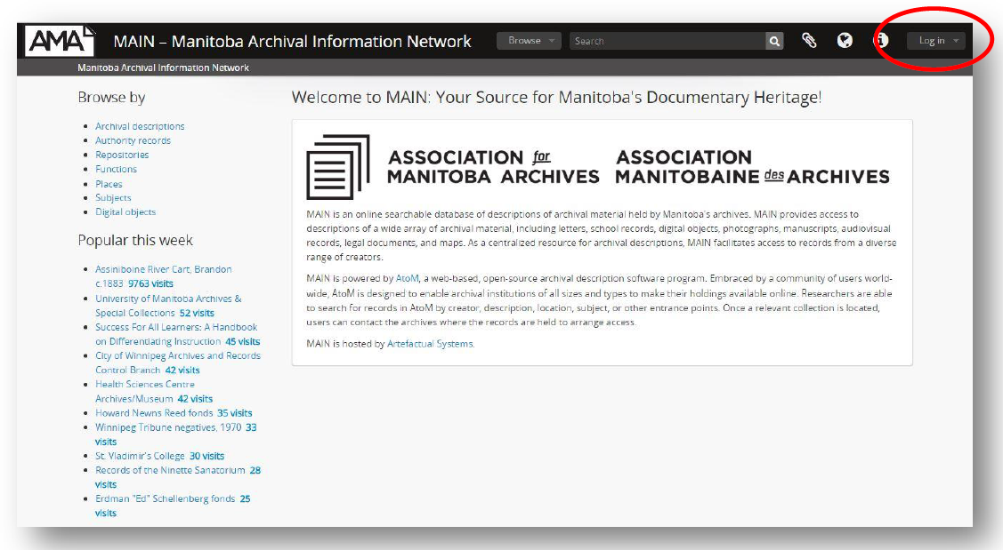

- Enter your Email and password. Click the Log in button.
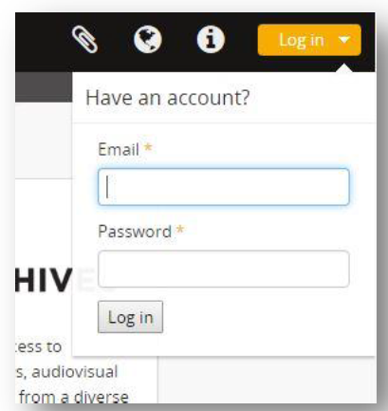

1.3 Changing Your Password
- Click on your name and then choose Profile.
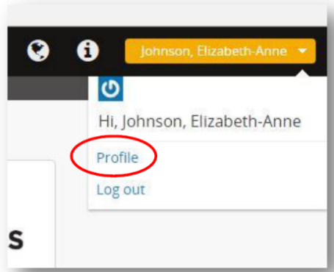

- Click Reset password
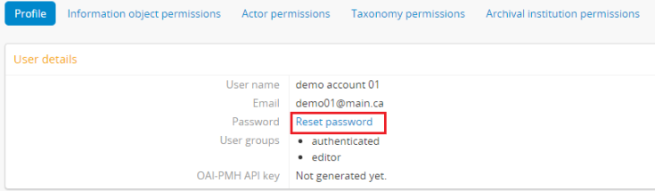

- Enter and confirm your new password when prompted.

1.4 Forgot Your Password?
If you have forgotten your password, e-mail the Digital Initiatives committee at webmaster@mbarchives.ca and request a password reset. You will receive a temporary password. To change the temporary password, follow the steps in 1.2 Changing Your Password.

1.5 De-activing an Account in Main
If you no longer require an individual account (e.g., if an employee at your institution has left and no longer requires access to MAIN), contact Digital Initiatives to de-activate their account to ensure that they can no longer access or edit your records.

1.6 Saving Content in MAIN
When creating or editing content in MAIN (e.g., entering descriptions or authority records), you should save your description habitually to prevent the loss of significant information in the event that the site crashes while you are working on your content. For longer content, we recommend you save the content locally (e.g., in a Word file on your desktop) to ensure your description is not lost in the event that a system failure in MAIN prevents you from saving a description.

STEP 2: Adding/Editing Authority Records
An authority record documents a person, family, or corporate body, including their authorized form of name, biographical or administrative history, dates of birth and death, etc. When creating an authority record, certain fields should be consistently used in MAIN. The following fields are mandatory for all authority records:
- Type of entity
- Authorized form of name
- Dates of existence
- History
- Maintaining repository
This section provides information on how to format and populate these fields, and other optional fields. Some lesser used fields are not discussed in this guide. However, more information on these fields can be obtained through MAIN, by clicking in the field of interest.
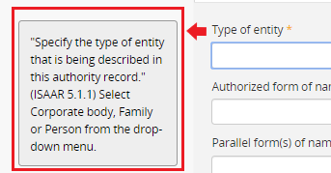
When you click in a given field, a note will appear to the left of the field, providing details on what information should be entered into the field, as well as a reference to the section of the International Standard Archival Authority Record for Corporate Bodies, Persons and Families, or ISAAR(CPF) for more information.
Prior to creating an authority record, search MAIN to ensure that there is not an existing authority record for the entity you are describing. You can do this by clicking on the Browse button, clicking Authority records, and doing a keyword search in the search field.
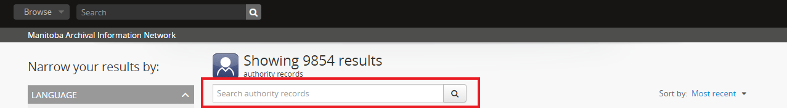
If an authority record already exists for your entity, you should merge your description with the existing authority record, so that users interested in the creator can access all records related to the creator through a single authority. To do so, contact the institution that created the authority record and discuss potential options, including linking to their authority record, or merging both authorities to create a more detailed record. The maintaining repository can be found in the Maintained by field in the Control area section (see 2.4 Control Area). If the authority record does not already exist, follow the steps below.
- Click on the Add button in the top toolbar and select Authority records.

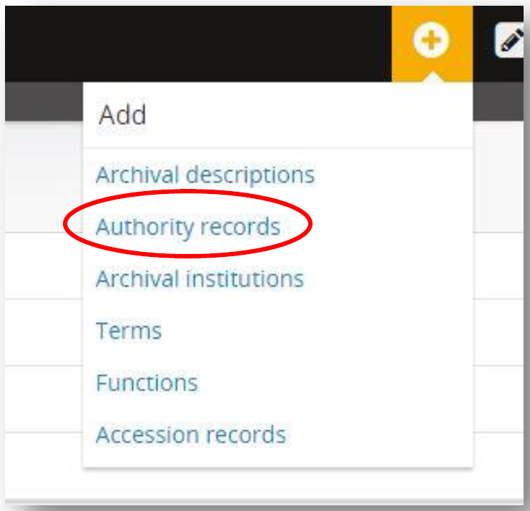

2.1 Identity Area
- Click Identity Area
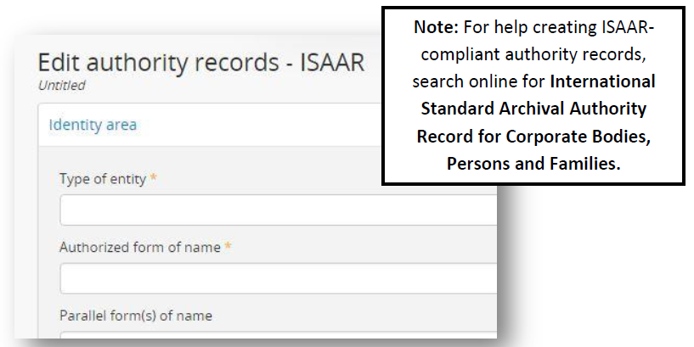

- Select the Type of Entity that applies to your authority from the drop-down menu.
- Enter the entity’s Authorized form of name in the appropriate format. If a Library of Congress authority exists for your authority record, use the same format for the Authorized form of name as the Library of Congress standard. To search for a Library of Congress authority, go to http://id.loc.gov/authorities/subjects.html and select LC Name Authority File (LCNAF) in the dropdown menu. Enter your authority name in the search field and click Go.
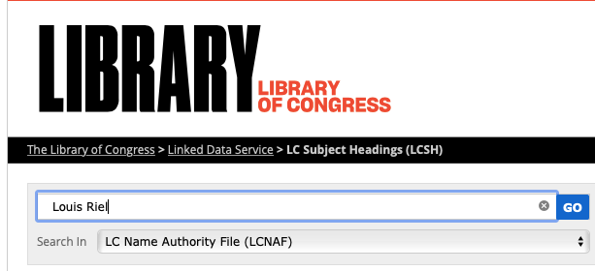

- If an authority heading does not exist for your authority record, use the following:
  - For persons, use the format: “[Surname], [Given Name], YYYY-YYYY” (e.g., “Smith, Jane, 1900-1999”).
  - For corporate bodies, write the official name of the organization in full. Do not use acronyms (e.g., use “Winnipeg Regional Health Authority”, not “WRHA”)
  - For families (i.e., an authority record that describes more than one person with a familial or marital relationship), use the format “[Surname] family” (e.g., Smith family)

2.2 Description Area
- Click Description area
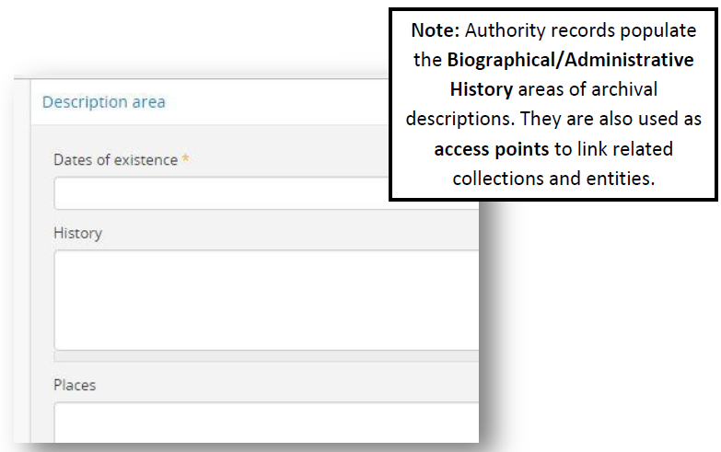

- Enter the entity’s Dates of existence (e.g., 1922-2015, or 1985-). Note: If your authority is still in existence, leave the date open ended. Do not add a word to describe its status (e.g., 1900-present, 1900-today, 1900-ongoing).
- Under History, enter biographical information for a person or family (e.g., place(s) of birth, achievements, family, etc.) or an administrative history for your corporate body (e.g., mandate, professional activities, affiliations, etc.). Use dates as much as possible (e.g., In 1989, Jane Smith received an award for…”).

2.3 Relationships Area
- The relationship area allows you to link your authority records to other authorities and establish a relationship (e.g., one authority is the sibling of another).
- If you are adding a relationship, you MUST save your authority record BEFORE doing so by clicking the Create button at the bottom of the page. If you are not adding a relationship, proceed to step 2.4 Control Area.
- Once you’ve saved your description, click Edit at the bottom of the page.
- Click Relationships area.
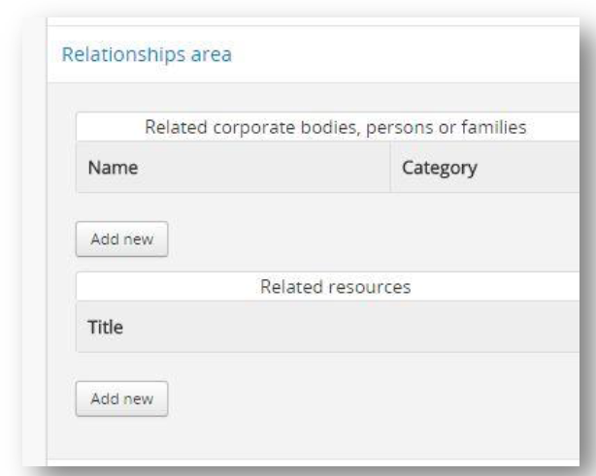
- If there are existing entities in MAIN that relate to the entity being edited, choose Add new under Related corporate bodies, persons, or families.

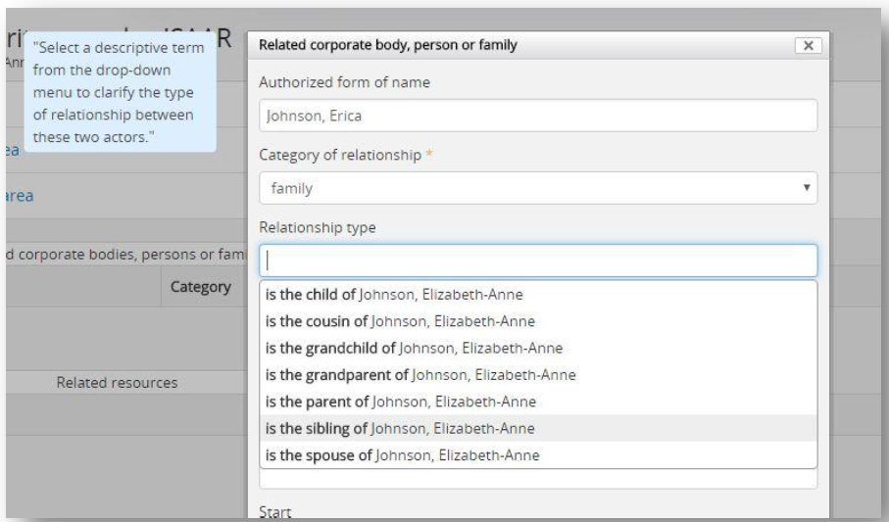

- Search for the related entity by typing its name in the Authorized form of name field, then choose its name from the list that appears.
- Choose the Category of relationship from the drop-down list.
- Choose the Type of relationship by clicking in the box and then choosing from the list that appears.
- Enter the Description and Dates of the relationship if you know them and click Submit.

2.4 Control Area
- Click Control area
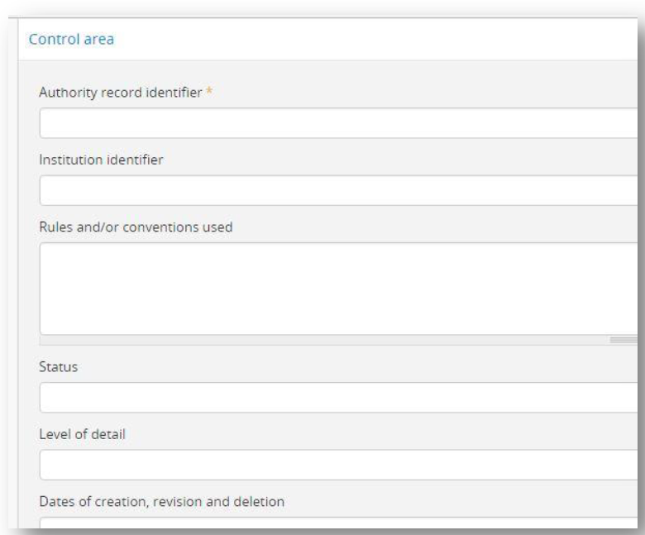

- If your institution has Authority record identifiers, enter the identifier in that field.
- Start typing in the name of your institution in Maintaining repository and click on it in the drop-down list. Do not hit enter. Hitting enter will create a duplicate entry for your institution.
- If your institution uses a repository identifier, add it in the Institution identifier field.
- Choose the record’s Status and Level of detail from the drop-down menus.
- Enter the Date of creation, revision or deletion in the appropriate box, along with your name.
- Cite any information you used to create your authority record in the Sources field.
- List any notes you have about the creation or maintenance of this record in the Maintenance notes box.
- Click the Create (or Save, if you’re editing) button at the bottom of the page to save your authority record.

STEP 3: Adding/Editing Archival Descriptions in MAIN
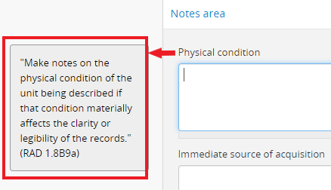
Archival descriptions provide users of MAIN with important contextual information about records held by a given repository. Descriptions are typically hierarchical, meaning that they have multiple levels (e.g., fonds, series, files, items). This section will review how to populate top-level descriptions specifically (e.g., fonds or collection), but can be used to populate any level of description once you add child levels (see Step 4). This section will focus on more commonly used fields. However, information on how to populate other fields can be found in the Rules for Archival Description (RAD) documentation or by clicking on any field in your description.

A note will appear to the left of the field, providing details on what information should be entered into the field, as well as a reference to the section of RAD that describes the purpose of the field in more detail (e.g., 1.8B9a in the above screenshot).
- Click on the Add button in the top toolbar and select Archival descriptions
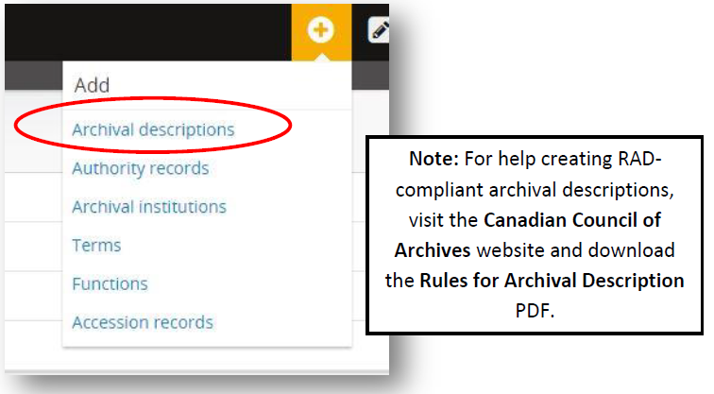

3.1 Title and Statement of Responsibility Area
- Click Title and statement of responsibility area.
- Under Title proper, enter the title of your fonds or collection, often in the form of “[Creator name] fonds” or “[Creator name] collection”. Note: For top-level descriptions, always include, in lower case, “fonds” or “collection” in your title field (e.g., “John Smith fonds” not “John Smith” or “John Smith Fonds”).
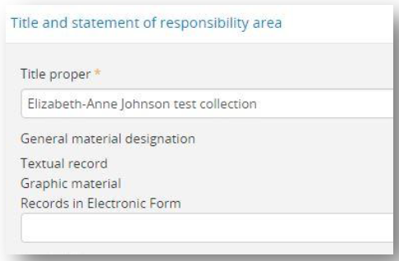
- Under General material designation, select the material type(s) of your collection from the drop-down list. If your collection contains more than three material designations, choose “Multiple media”.

- If you mistakenly select an incorrect material designation, click on it to delete it.
- Under Level of description, select the correct level from the drop-down list.
- In the Repository field, begin typing your repository’s name in the appropriate box. Once your repository’s name appears, click on it in the drop-down list. Do not hit enter. Hitting enter will create a duplicate repository.
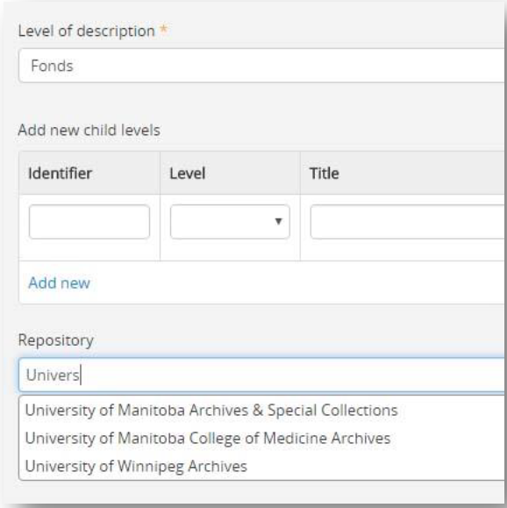

- In the Identifier field, enter your repository’s unique identifier for the fonds or collection.

3.2 Dates of Creation Area
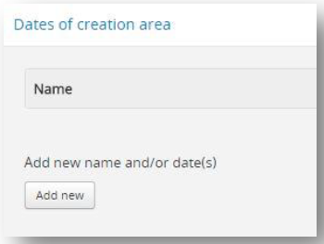
Click Dates of creation area

- Click Add new

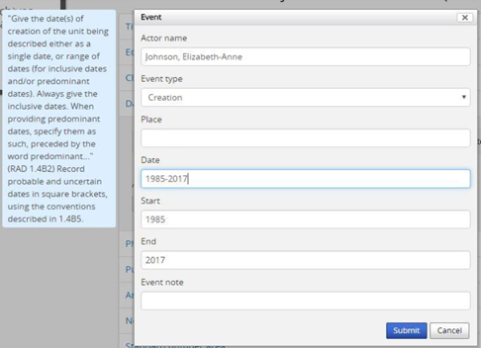

- In the Actor name field, begin typing the name of your authority record. Once the name appears, click on it in the drop-down list. Do not hit enter. Hitting enter will create a duplicate actor name. Note: Enter your actor name in the same format that it appears in the authority record (e.g., if your authority is titled “Smith, John”, it will only appear if you start to type it as “Smith, …” and not “John …”).
- Under Event type, select the type of event from the drop-down menu.
- Under Place, begin typing the name of the place of the event if relevant. Once the place name appears, click on it in the drop-down list. Do not hit enter. Hitting enter will create a duplicate place name.
- In the Date field, type in the date(s) of the event according to RAD guidelines (section 1.4). For simple dates (e.g., “1950-1960”), the Start and End fields will fill in automatically. For complex dates (e.g., “ca. 1960”, “[before 1950]”, “[195-?]”), the Start and End fields should be entered manually. These fields allow people to find relevant material when searching by date, so enter the dates accordingly (e.g., ca. 1960 could be 1950-1970 – use best judgement). If adding a precise date, dates should be entered in yyyy-mm-dd format.
- Click Submit.

3.3 Physical Description Area
- Click on Physical description area.
- Enter the extent of the unit(s) being described according to RAD guidelines (section 1.5).
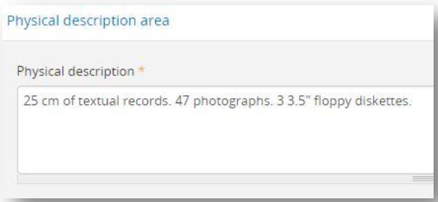

3.4 Archival Description Area
- Click on Archival description area
- The Biographical sketch is not visible when creating a record. Once saved, it will automatically populate the completed description with information from the creator’s authority record, which was linked via the Actor Name field populated in step 3.2.
- Enter the Custodial history of the unit(s) being described.
- Enter the Scope and content of the unit(s) being described.
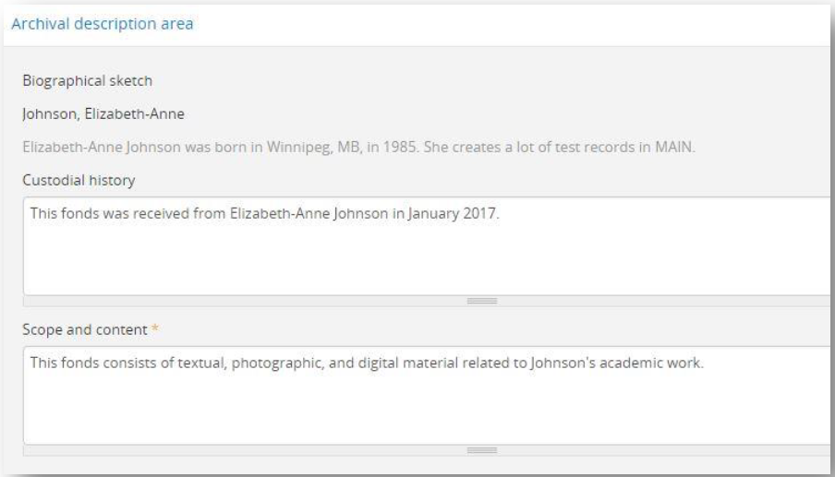

3.5 Notes Area
- Click on Notes area.
- Enter any notes you have about the item(s) being described in the appropriate areas.
  - While most fields allow for free-form text, certain fields in this area MUST be populated by clicking on items that appear in the drop-down. These fields include:
    - Related materials: Start typing the title or identifier of a related description
    - Language of material: Begin typing the language in which the material is recorded
    - Script of material: Begin typing the name of the language in which the script is recorded
- To populate these fields, begin typing the information and once the correct item appears, click on it in the drop-down list. Do not hit enter. Hitting enter will create duplicates.

3.6 Access Points
- Click on Access points
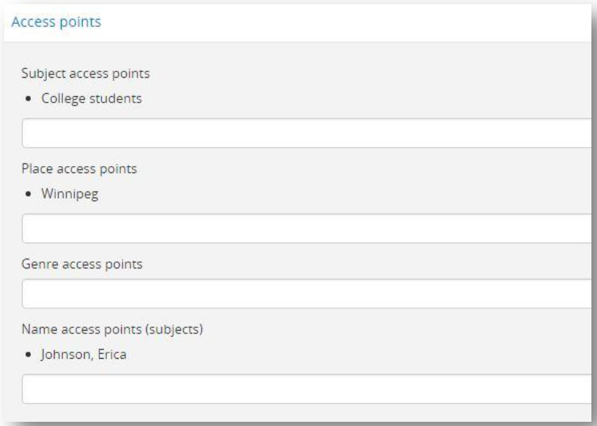
- Begin typing Subjects, Places, or Names in the appropriate box. When it appears, select the correct term in the drop-down menu. Do not hit enter. Hitting enter will create duplicate access points.

- Note: Subjects conform to the Library of Congress’ FAST Subject Headings. Please view the MAIN Policy Guide before adding access points to your description.

3.7 Control Area
- Click on Control area.
- Choose the Status of the description: “draft” (not yet revised), “revised” (changes/additions have been made), or “final” (no future additions or revisions are expected) – from the drop-down menu.
- Choose the Level of detail of the description – “full” (includes all applicable elements in the description), “partial” (includes all mandatory elements), or “minimal” (does not include all mandatory elements) – from the drop-down menu.
- Enter the Dates of creation, revision, and deletion of the level of the description and your name.
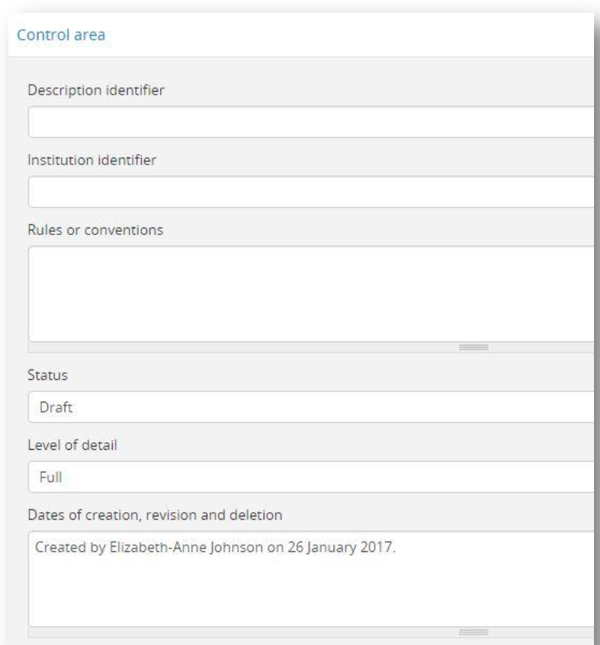

- Cite any information you used in the creation of this description in the Sources field.

3.8 Saving Your Description
- Once you’re done populating your description fields, click the Create button at the bottom of the page. Or, if you have already created the description and are simply editing it, click Save.

STEP 4: Adding Child Levels to Existing Archival Descriptions
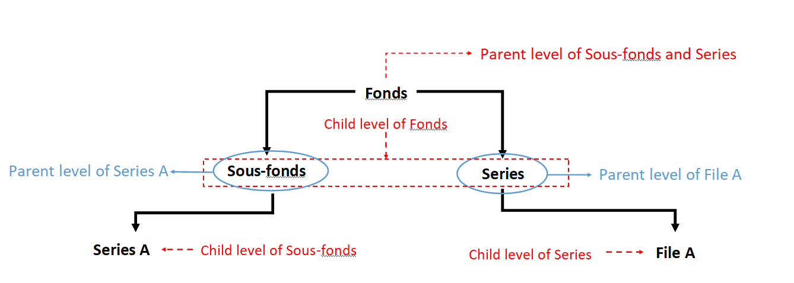
Child levels are descriptions that fall under higher levels of archival description, or “parent level” descriptions. If your highest level of description is a fonds or collection, the next levels down are likely sous-fonds or series. In the scenario outlined below, the fonds is the parent level, and the sous-fonds and series directly linked to it are its child levels. Alternatively, if your series have files, the series would be the child level of the fonds but the parent level of the files.

4.1 Creating Child Levels – Method One
- Navigate to the description to which you want to add child levels (e.g., if you are adding a series, go to the parent fonds-level description for that series). At the bottom of the page, click Add new.
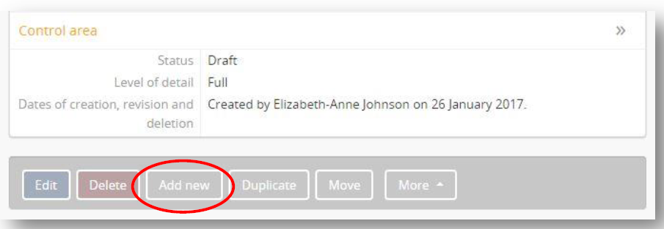

- Fill out the appropriate fields as discussed, starting from Step 3.1. Make sure to select the level that applies to the new child level you are creating under Level of description in the Title and statement of responsibility area.

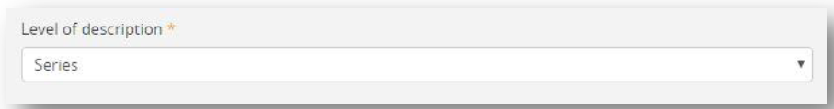

- When all relevant fields are populated, click Create at the bottom of the page.

4.2 Creating Child Levels – Method Two
- Navigate to the description to which you want to add child levels. Click on Title and statement of responsibility area.
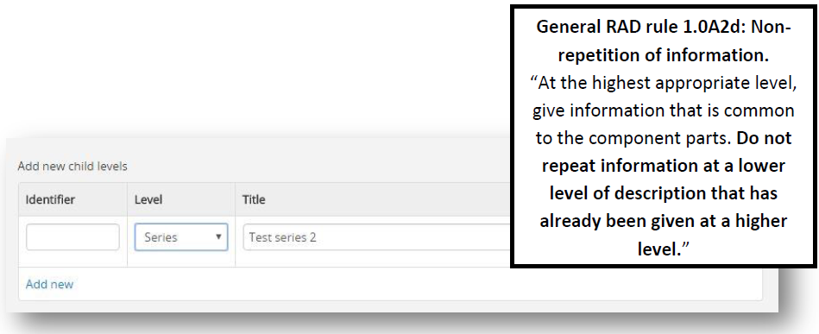
- Scroll down to Add new child levels.

- Choose the Level of description you would like to add from the drop-down menu.
- If your institution assigns an identifier to a given level of description, enter it in the Identifier field.
- Enter the Title of the new child level
- Enter the date(s) of the new child level
- Click Add new (or press the Enter key) to add another child level. Note: By default, when you add new child levels, the Level of description field will be prepopulated with the last level of description you selected.
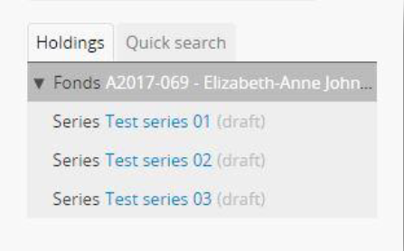
- Once you are done adding new levels of description, click Save at the bottom of the page. You should see the new levels in the tree view on the left-hand side of the screen. Note: If the levels of description do not appear in the right order, see Step 5.1.

- To add more information to the child levels created using the second method, you must click on each level in the tree view and edit them individually (see Step 3.1 - Step 3.8).

STEP 5: Arrangement Features

5.1 Moving Levels of Description
- A child level of a description can be moved to a different parent by clicking on the Move button at the bottom of the description you wish to move.
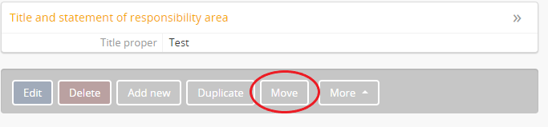
- In the search field, enter the title of the parent level description to which you wish to move your child level description, and click on the magnifying glass icon to search. Click on the hyperlinked title of the level for which you are searching.

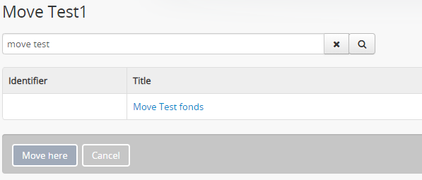

- Once you’ve clicked on the hyperlink, you will see any other child levels that are linked to the level of description you selected in the previous step. If you click Move here, your description will be linked to the parent level of the child levels listed. Or, you can click on one of these child levels if you wish to make it the parent level of the description you are currently moving.

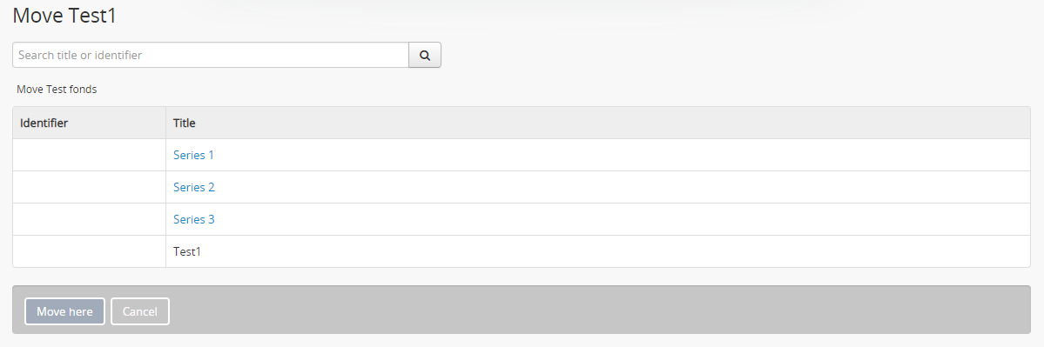
- By default, your level of description will be listed last among other child levels already found under the parent level to which your description was moved. You can change this order by following the steps in step 5.1.2.

5.1.2 Dragging and Dropping Child Levels
- You can change the order of child levels linked under the same parent level description by dragging and dropping the files in the tree view. Note: You cannot drag and drop a level of description to a different parent level description.

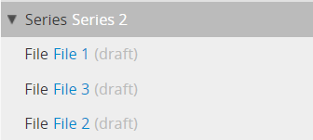

- Click the description level you want to move, holding the mouse button down until you have dragged the level of description to the correct location. The file you selected will disappear from the tree view, appearing outside of it.

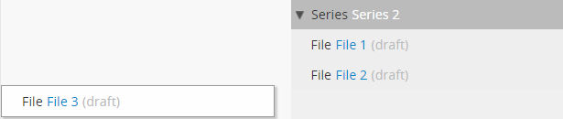

- Drag your mouse to the correct location to re-order your level(s) of description and let go of the mouse. The tree view will refresh and your child levels should appear in the correct order.
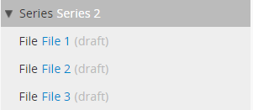

5.2 Duplicating Descriptions
- You can use previous descriptions as a template for new descriptions by clicking on the Duplicate button at the bottom of the level of description you wish to use as a template.
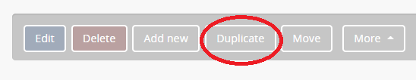
- Note: The duplicate will appear as a stand-alone level of description. Consequently, if you are duplicating a child level description, you will have to link it to the correct parent level description (see Step 5.1).
- A near-exact copy of your level of description should be created. It will not include an identifier, as a unique identifier will have to be assigned.
- If you are assigning a different title to the duplicated level of description, you may wish to update the URL as it will reflect the original level of description duplicated. For example, if your original level of description had the URL:
https://main.lib.umanitoba.ca/test-fonds, then the hyperlink automatically generated for your duplicated item would be https://main.lib.umanitoba.ca/test-fonds-1. To change the URL ending, see Step 5.3.

5.3 Changing Slugs
- A Slug is the portion of your URL that follows main.lib.umanitoba.ca/. For example, the portion of the URL highlighted below is the slug:
  - Main.lib.umanitoba.ca/test-fonds
- You can alter your slug by clicking on the More button at the bottom of the description you wish to edit and select Rename.
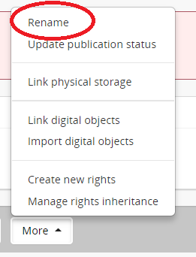

- Updating the title field will automatically change the title of your level of description and the slug. The slug will mirror the title, replacing spaces with hyphens and removing any punctuation from the title. For example, a level of description titled Test fonds will generate the slug test-fonds. Similarly, a level of description titled John “Jack” Smith fonds will generate the slug john-jack-smith-fonds, removing the quotes from the title.
- To change your slug, but not your title, edit the slug field. Any edits that do not conform to the slug formatting rules will be auto-corrected once you click outside of the field.
- If you choose a slug that already exists in MAIN, it will automatically add a number to differentiate it (e.g., if test-fonds already exists, the slug will be test-fonds-1).
- When you have made your changes, click Update.

5.4 Deleting Descriptions/Authorities
- Depending on your level of access, you may or may not have the ability to delete descriptions. If you do not have the ability to delete, it may be that another person in your institution is responsible for deleting content. If no one in your institution is able to delete content, you may request deletion permissions from Digital Initiatives.
- If you have deletion permissions, you will notice a red “Delete” button at the bottom of either a description or authority record page.
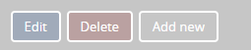

- Note: By deleting a level of description, you are deleting ALL child levels of description linked to it. For example, if you delete a fonds with linked series and objects, you will not only be deleting the fonds, but all the series, and any levels or objects linked to those series as well. Similarly, if you delete a series, you will be deleting all linked subseries and/or files. Consequently, it’s important to make sure you only delete the intended descriptions.
- Once you click delete, you will be asked to confirm whether you want to delete the selected entry. For levels of description, information on the linked levels that will be deleted alongside the parent level description will be provided. If you are sure you want to delete the description or authority and any linked content, click “Delete”.
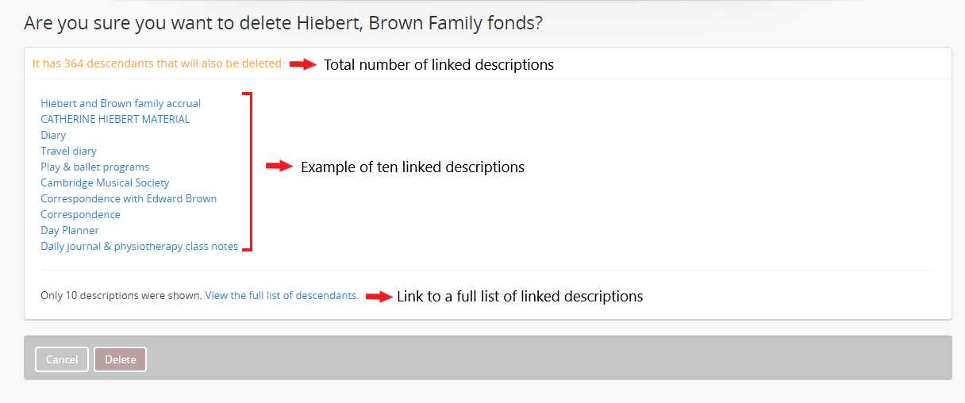

- It is also important to note that while deleting a level of description will delete linked descriptions, it will not delete other types of linked information. For example, if you wish to delete an entire fonds or collection, your authority record will still exist, unlinked from the description. If you wish to delete all content related to the description, you will have to delete some content separately.
- If you delete a significant amount of content at once, MAIN can become overloaded and the server can sometimes freeze up, causing a 500 error for anyone attempting to access it. To avoid this, try to delete smaller levels of description and work your way up (e.g., delete each series individually and then their parent fonds). If this isn’t possible due to quantity, contact Digital Initiatives and we will delete the description for you.

STEP 6: Finalizing your MAIN descriptions

6.1 Publishing Your Descriptions
- All descriptions you create are automatically saved as Draft. To publish a description, go to the level you wish to publish (to publish a description and all related child levels, select the highest level). Click on the More button and select Update publication status.
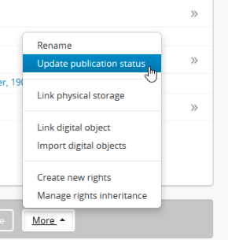
- Under Publication status select Published from the drop-down menu. To apply this change to all lower-level descriptions, check the Update descendants box.
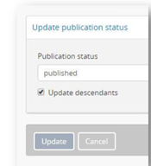

6.2 Generating a PDF Finding Aid
- A PDF can be generated from your description to allow users to download your finding aid. To generate a pdf, your description must already be published (see Step 6.1). Once it’s published, on the right-side of your description, click Generate under Finding aid.
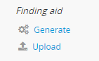
- Your finding aid area should then change to show your pdf finding aid is in progress.
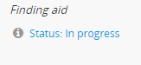
- If you remain on the description page once you’ve clicked Generate, the Status: In progress message appearing under Finding aid will remain. You must refresh the page to see if the PDF is finalized. You may also close your browser and check back on the finding aid later. Larger finding aids will take longer to generate.
- When the PDF has been generated, you should see Status: Generated, as well as a link to Delete the pdf finding aid, and a Download button to go to the generated PDF.
- If changes are made to your finding aid at a later date, you should delete the existing pdf and generate a new one to ensure the changes are included.
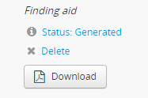

6.3 Uploading an Existing Finding aid
- If you have an existing finding aid that you would like to upload, click on the Upload link under Finding aid. Note: Your finding aid must be in PDF format for this step.

- Click on Choose file and select your PDF finding aid.
- If you remain on the description page once you’ve clicked Generate, the Status: In progress message appearing under Finding aid will remain. You must refresh the page to see if the PDF is finalized. You may also close your browser and check back on the finding aid later. Larger finding aids will take longer to generate.
- Once your PDF is uploaded, the status will change to Status: Uploaded.
- If changes are made to your finding aid at a later date, you should delete the existing pdf and upload a new one to ensure the changes are included.
- Do not upload a finding aid as a digital object following the instructions in step 7. Digital objects should only be uploaded if they are part of a repository’s holdings (e.g., a digitized photograph from a collection).

STEP 7: Uploading Digital Objects
For the purpose of this document, a Digital object refers to a “born-digital” or digitized copy of an archival record in your repository, such as scanned documents or photos, or photos from a digital camera. These objects are uploaded to MAIN so that they can be accessed by researchers and others. Records such as finding aids or internal documents do not qualify as digital objects and should not be uploaded to MAIN through the methods outlined in this section. To learn more about digital objects in MAIN, see the Digital Objects section of the MAIN Policy Guide.
Note: You can only link one digital object to each level of description (e.g., one per item). However, you should be selective of the objects you upload. Objects uploaded to MAIN should only provide an overview or sample of a repository’s holdings, as MAIN has limited space.

7.1 Uploading a Digital Object
- From the description to which you want to add digital objects, click More at the bottom of the page. Choose Link digital objects.
- Click on the Upload a digital objects [sic] to expand.
- Click on Choose file and browse to and select your file.
- Click Create.
- A thumbnail of your object should appear at the top of your description. To get to the full image, click on the thumbnail.
- Click on the arrow to the right of the digital objects metadata area to add additional metadata about the digital object.

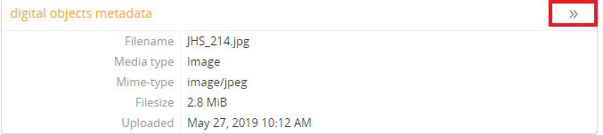

7.2 Linking to external digital objects
- At the bottom of the description to which you’d like to link a digital object, click More and then Link digital objects
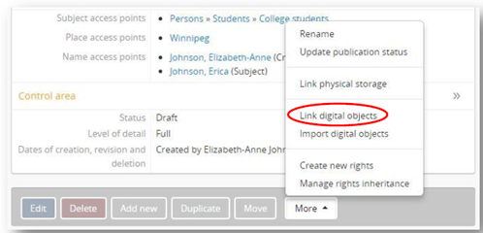
- Under Link to an external digital objects [sic], enter the URL of the object you’d like to link. Then click Create.
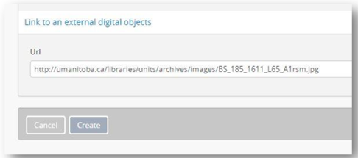

- A thumbnail of your object should appear at the top of your description. To get to the full image, click on the thumbnail.
- Click Edit to add additional metadata about the digital object.
- Objects linked to descriptions will also show up as thumbnails in the searchable list of collections.
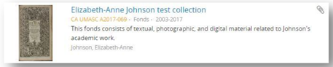

STEP 8: Editing Repository Pages

8.2 Setting-up a New Repository Page
- If your repository is new to MAIN and you do not yet have a repository page, contact the Digital Initiatives Committee to set-up a page. Note: You must be an accredited member to have a page. You should also be able to fill out a minimum number of fields so that users of MAIN know how to reach your institution and gain access to records you hold.

8.2 Editing Your Repository Page
- To edit your description, find your institution in the repository list by clicking on the Browse button and clicking on Repositories.
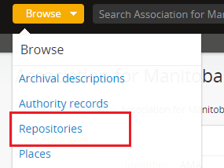

- Select your repository from the listed options.
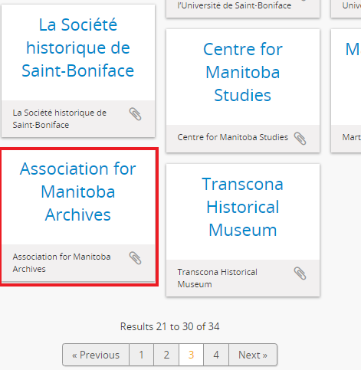

- From your repository page, click Edit.

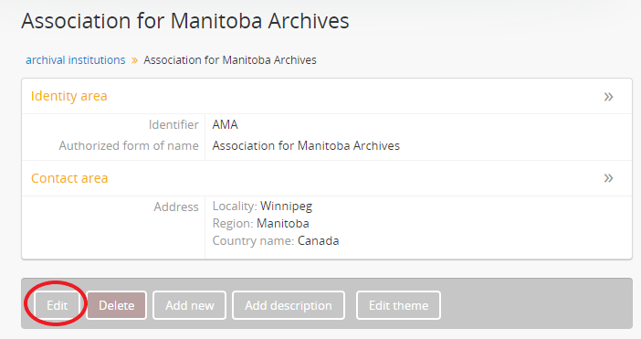

- Update your fields as needed. If you click in a given field, more information about how to populate the field will appear. A reference number to the relevant section in the International Standard for Describing Institutions with Archival Holdings will also appear. When you are done updating your repository, click Save.
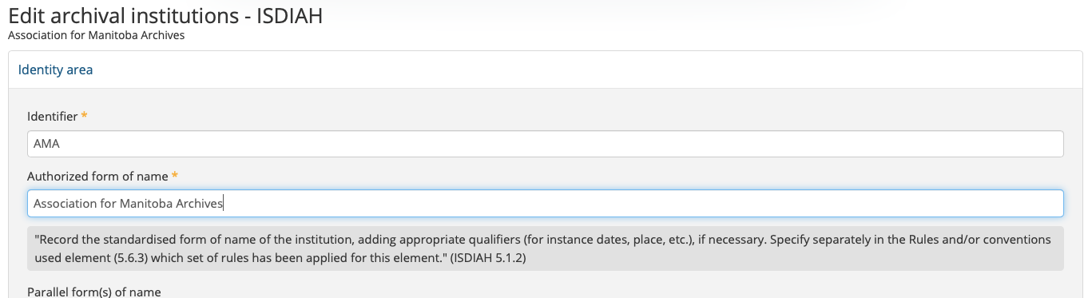
- To edit the look of your repository page, click on Edit theme.
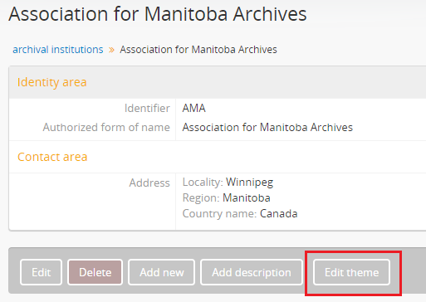

- To change the background colour of your repository page, and all descriptions linked to your repository, select a colour in the Style area.
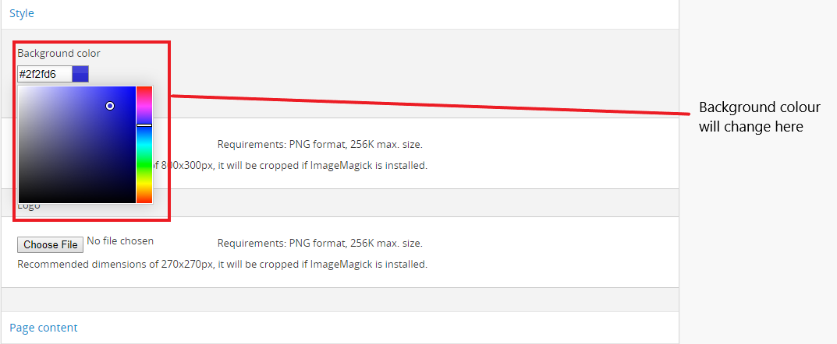

- Choosing a background colour may affect the contrast between some of the text that appears on the page and make it difficult for people who are visually impaired to read the text. When selecting a background colour, make sure users can still clearly read text such as the Add link under the Clipboard section.
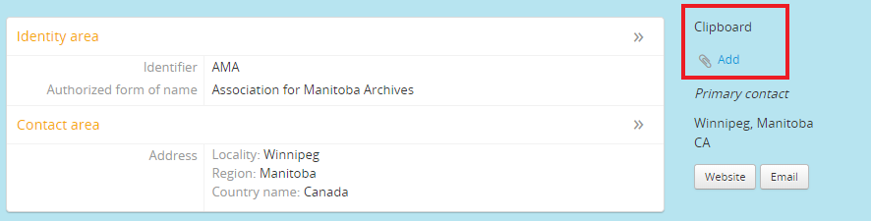

- To add a banner or logo, click on Choose File in the Banner or Logo area respectively. Select the file you wish to use for your banner/logo. Note: The file should be saved as a PNG and may have to be cropped or resized to appear properly.

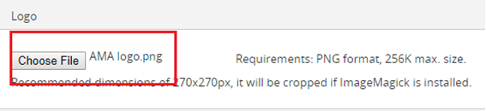

- Click Save.
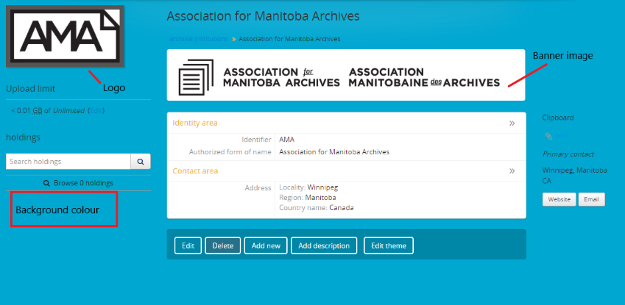

Further Information and Resources
Association for Manitoba Archives MAIN Tutorials, Policies, and Resources
http://mbarchives.ca/AtoM-Tutorials
AtoM Documentation
https://wiki.accesstomemory.org/Resources/Documentation
AtoM Users Google Group
https://groups.google.com/forum/#!forum/ica-atom-users
International Standard Archival Authority Record for Corporate Bodies, Persons and Families
https://www.ica.org/sites/default/files/CBPS_Guidelines_ISAAR_Second-edition_EN.pdf
International Standard for Describing Institutions with Archival Holdings
https://www.ica.org/en/isdiah-international-standard-describing-institutions-archival-holdings
Library of Congress FAST Subject Headings (for subject access points)
https://fast.oclc.org/searchfast/
Library of Congress Subject Headings (Use only for authorities)
http://id.loc.gov/authorities/subjects.html
Rules for Archival Description
http://www.cdncouncilarchives.ca/RAD/RADComplete_July2008.pdf

